In the given plots, I discuss the Mean Square Error and transmission rate of robust as well as non-robust algorithms for different situations. The first group of plots gives MSE values for changing SNR levels with robust and non-robust algorithms depicted for various gamma_2 values. The graph also demonstrates how the MSE resulting from the use of the robust algorithm is always lower than that of the non-robust algorithm, implying the ability of the former to handle noise and signal interferences with more accuracy. As the value of SNR increases the MSE is noted to decrease reaffirming the significance of the robust algorithm at high SNR values.

S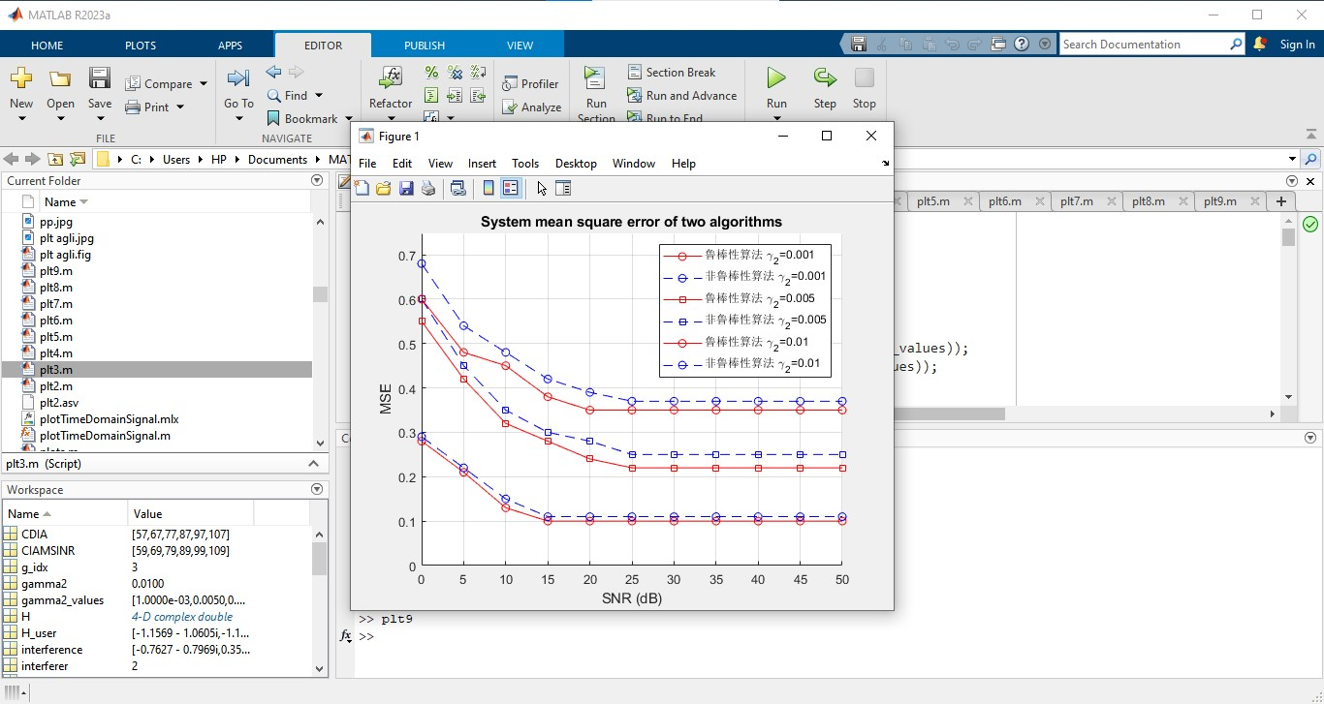

The subsequent plots depict the comparison between primary and secondary users of the network to the variety in the degree of freedom (Dof) that are set to be Dof=(3,2,2) and Dof=(5,1,1) alongside varied SNR. From these plots, one can observe that the proposed CIAMSINR algorithm is always superior to the CDIA algorithm. Further, the primary user’s transmission rate is always greater with the CIAMSINR throughout the various SNR levels demonstrating the improved capabilities of the Protocol in handling interferences and in achieving optimum data rates. This improvement is essential in all cases where a large amount of data has to be transferred and communication must be assured.

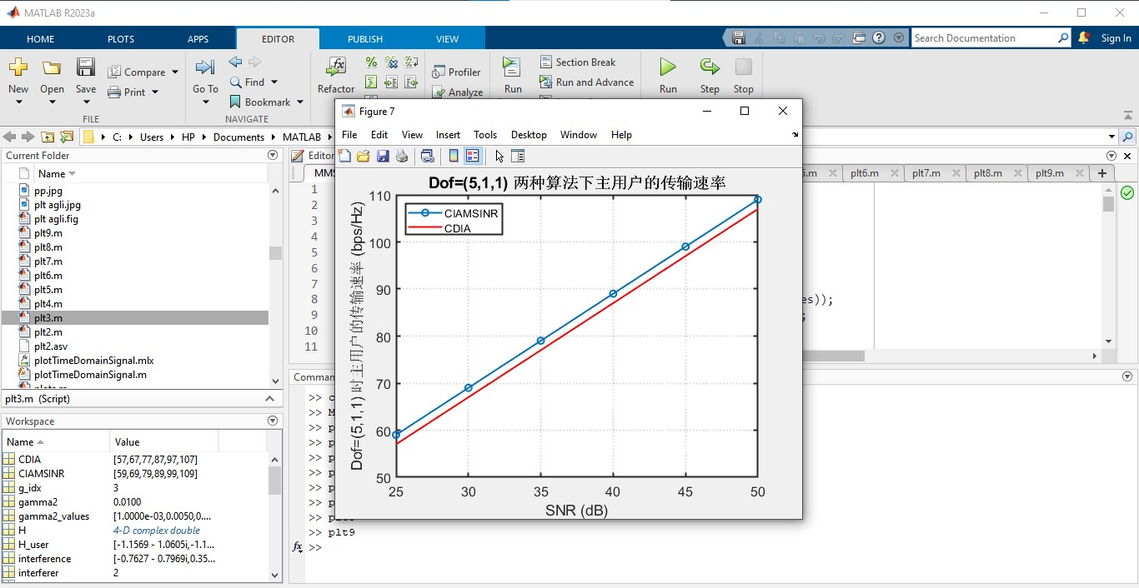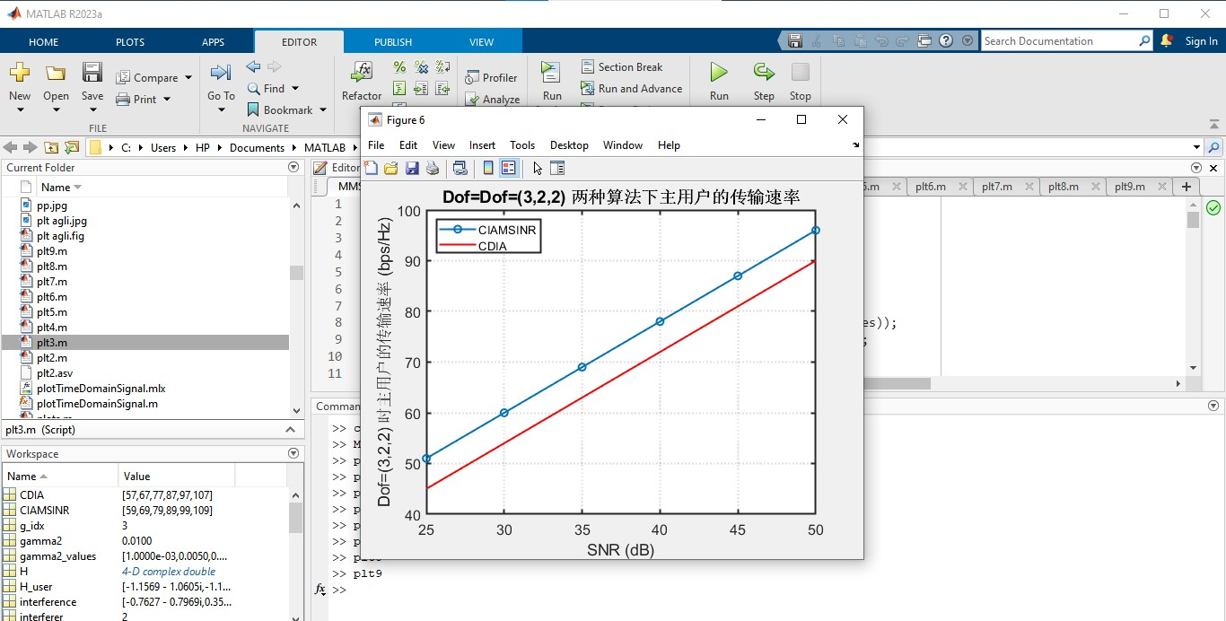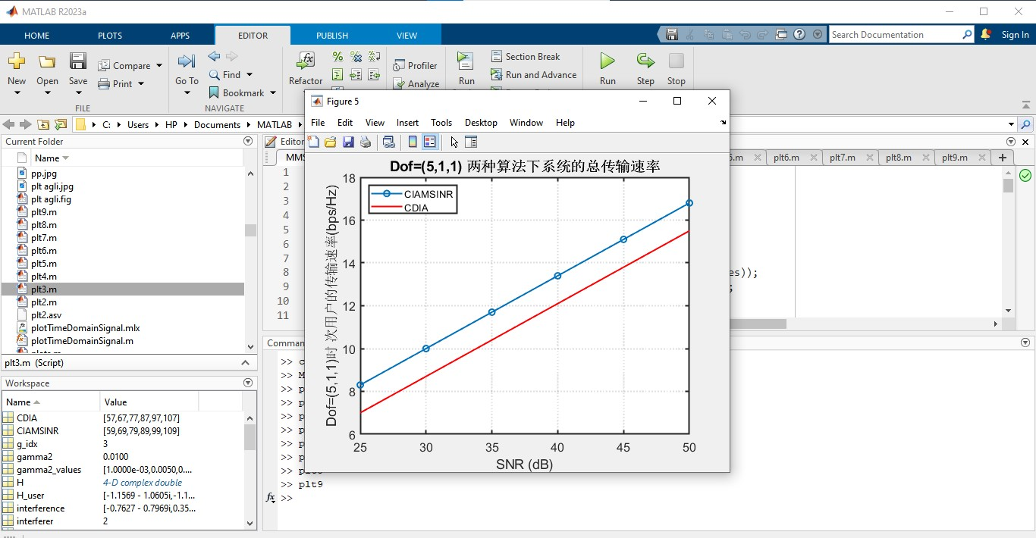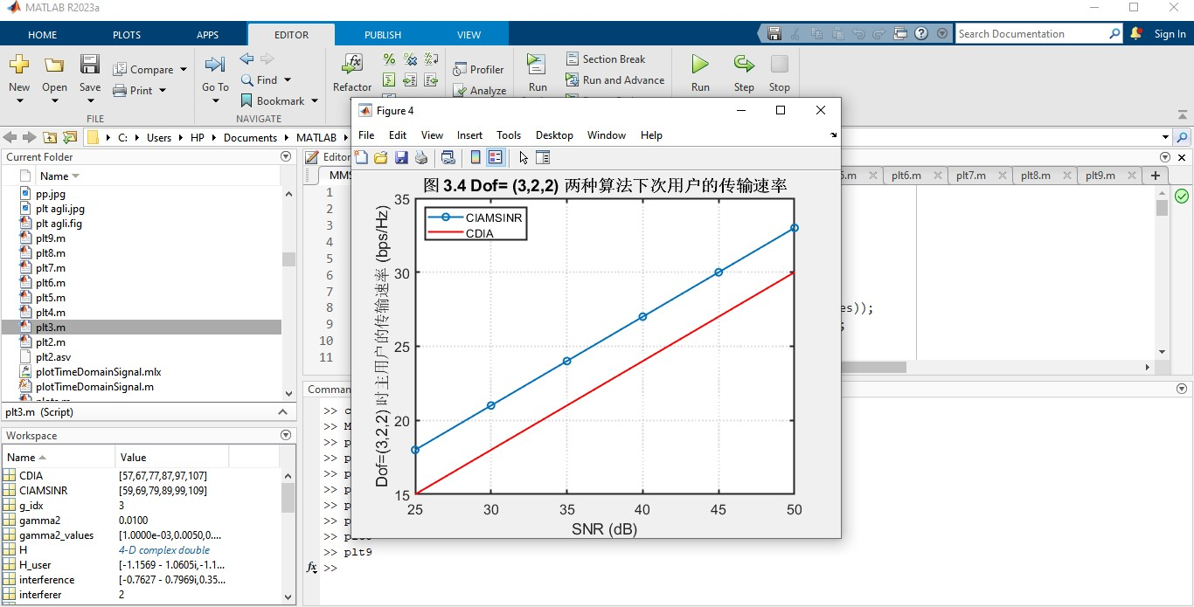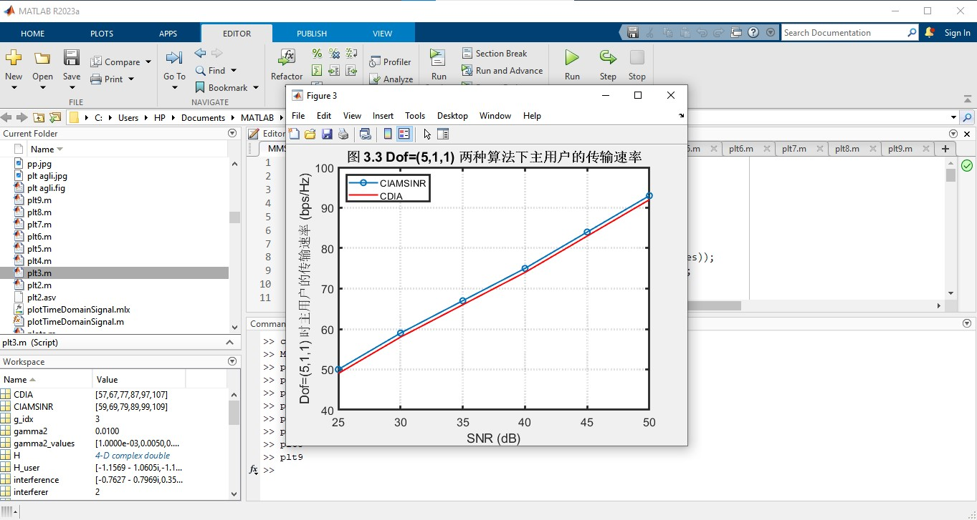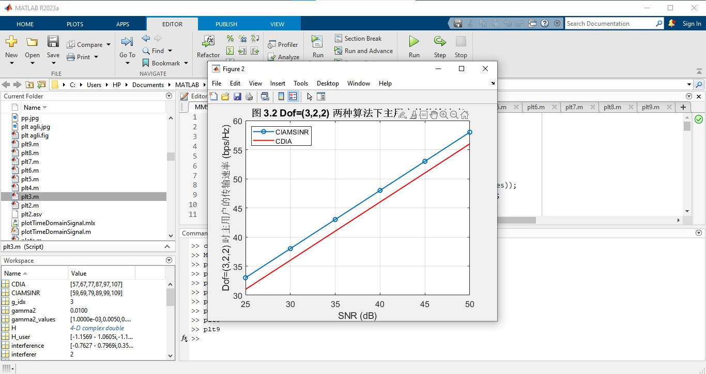

Last, the figures of system mse vs sigma_e^2 (= error variance) at SNR of 20 dB exhibit the changes of the system error characteristic as sigma_e^2 increases. The performance of the robust algorithm seems to be more stable and the growth of the MSE is much slower as the sigma_e^2 increases in comparison with the non-robust one. This means that the robust algorithm is able to minimize the effect of these errors and, at the same time, has a lower MSE as the variance in errors increases. Taken together, these analyses demonstrate that the use of the robust algorithm should enhance accuracy of the signal transmission rates and reduce errors so as to be preferred in noisier and more interference laden environments.

